|  |  |  |  |
| --- | --- | --- | --- |
| Name:  Class: | ____________________________________  ________________ | | Date:_________ |
|  | **Year 11 Essentials**  **Test 1, 2021**  **Topic – Number** | | / 45  5% |
| **Total Time:** | *46 min TOTAL* |  | |
| **Weighting:** | *5 %* |
| **Equipment:** | *1 A4 page of notes (one side) and Calculator (second section only)* | | |

**NON-CALCULATOR SECTION – 20 min**

**20 marks**

|  |
| --- |
| **Question 1*****4 marks*** |

Use an addition strategy to solve the following

|  |  |
| --- | --- |
| 1. 147 + 212 | 1. 562 + 226 |
| 1. 103 + 756 | 1. 233 + 145 |

|  |
| --- |
| **Question 2*****3******marks*** |

Order the following numbers from lowest to highest. The number line has been included to help you visualise their value.

$3 0.25 -3.2 0.75 4.75$

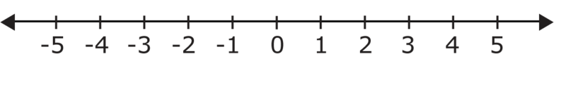

|  |
| --- |
| **Question 3** ***4 marks*** |

Use the subtraction strategy of your choice to solve the following

|  |  |
| --- | --- |
|  |  |
|  |  |

|  |
| --- |
| **Question 4 *3 marks*** |

Jack went to the shops and wanted to buy 2 packets of chips for $2.99 each, 3 mars bar for $1.95 each and a bottle of coke for $3.05. Estimate how much this would cost Jack. **Show your working**.

|  |
| --- |
| **Question 5 *2 marks*** |

Round the following numbers to number of decimal places in the bracket

1. 1.675 (1) b) 12.084 (2)

|  |
| --- |
| **Question 6  *4 marks*** |

Find the perimeter of the following shapes

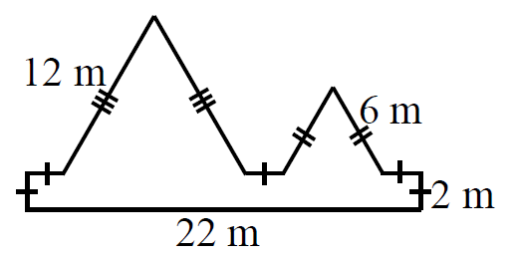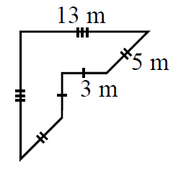

**CALCULATOR SECTION – 26 min**

**26 marks**

|  |
| --- |
| **Question 7 *8 marks*** |

Calculate the following

|  |  |
| --- | --- |
| 1. What is 30% of 70kg | 1. What percentage is 28 out of 40 |
| 1. $150 increased by 25% | 1. 900 decreased by 45% |
| 1. 40% of a number is 28. What is the original number? | |
| 1. A number is decreased by 35%, resulting in 162. What is the original number? | |

|  |
| --- |
| **Question 8 *3 marks*** |

Goh and Mei are arguing about who completed their maths assignment correctly. The question on the paper wanted them to evaluate $15-5×(6-4)$ using correct order of operations.

Goh argued that the answer was 20, while Mei argued that the answer was 5.

Who was correct and why?

|  |
| --- |
| **Question 9 *8 marks*** |

Use your knowledge of fractions, decimals and percentages to complete the table on the next page. Remember to simplify your fractions where possible and to round all your decimals and percentages to 2 decimal places if required. (9 marks)

|  |  |  |  |
| --- | --- | --- | --- |
|  | FRACTION | DECIMAL | PERCENTAGE |
| a) | $$\frac{1}{2}$$ |  |  |
| b) |  | 0.7 |  |
| c) |  |  | 25% |
| d) |  | 1.6 |  |

|  |
| --- |
| **Question 10 *7 marks*** |

Waseem made a purchase for a work outfit online. They sent him the following tax invoice, but there was a glitch in the file and some of the information was missing.

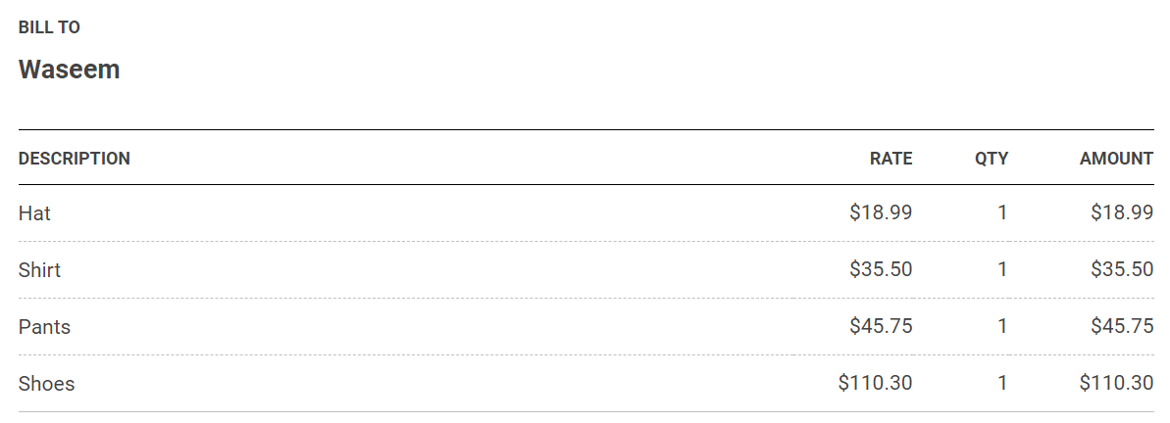

1. Calculate the total cost of his order, clearly showing the calculation that you would use.
2. In Australia, all products have a Goods and Services Tax (GST) of 10% applied to them. Calculate the total cost of Waseem’s order, after the GST was applied.
3. Waseem picked his order up in store and paid $300 cash. How much change did he receive?
4. When Waseem tried the shirt on, he found it was too small. He returned the shirt and received the cost of the shirt as a refund. What percentage of the original total did Waseem receive back?

**End of Test**